**Collect Metrics and Logs from Amazon EC2 instances with the CloudWatch Agent**

**First Step** -> create a role and give a **SSM** ,**cloudWatchAgentAdminPolicy** **&** **CloudWatchAgentServerPolicy** permission then click next tag.

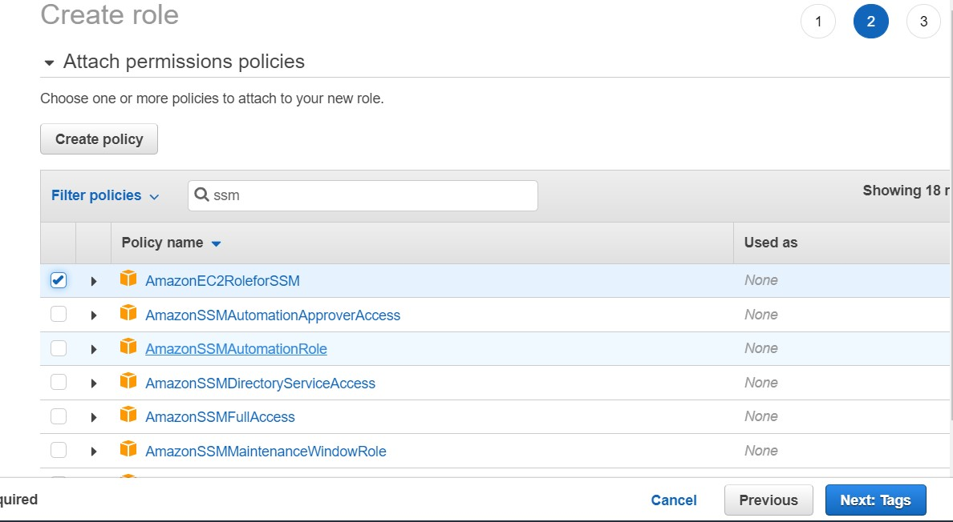

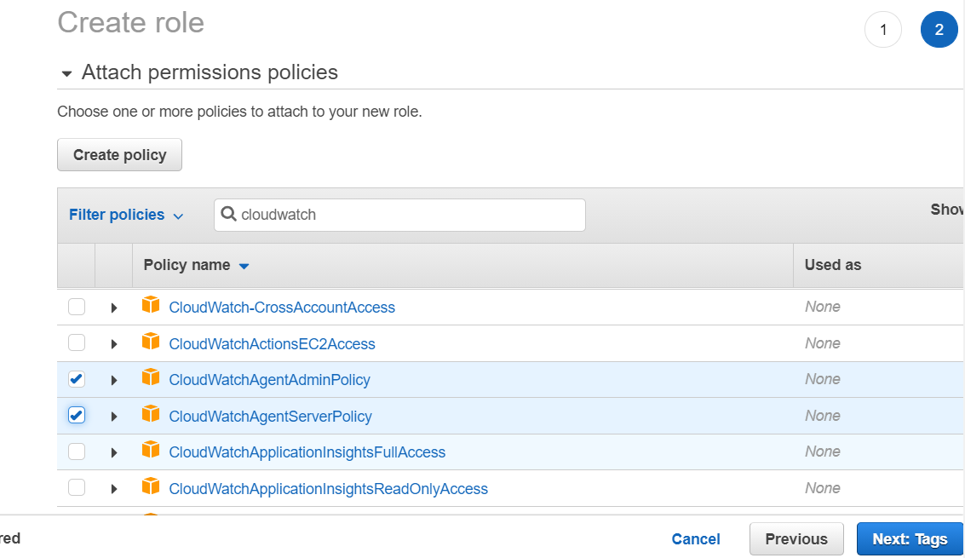

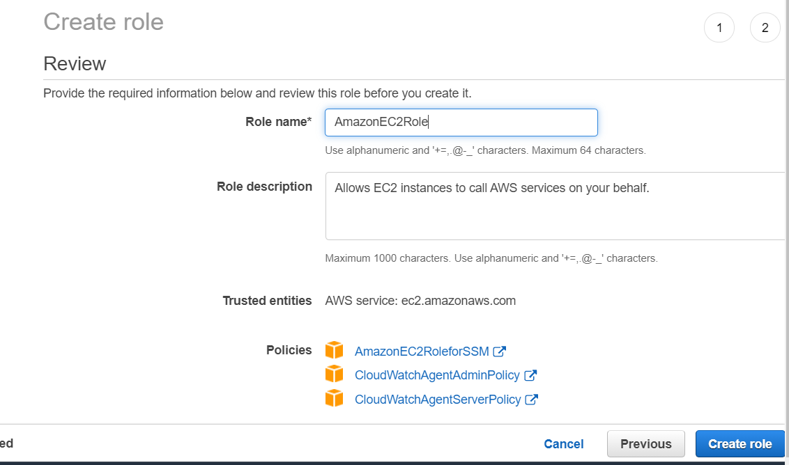

**Second Step ->**  **create a windows instance**

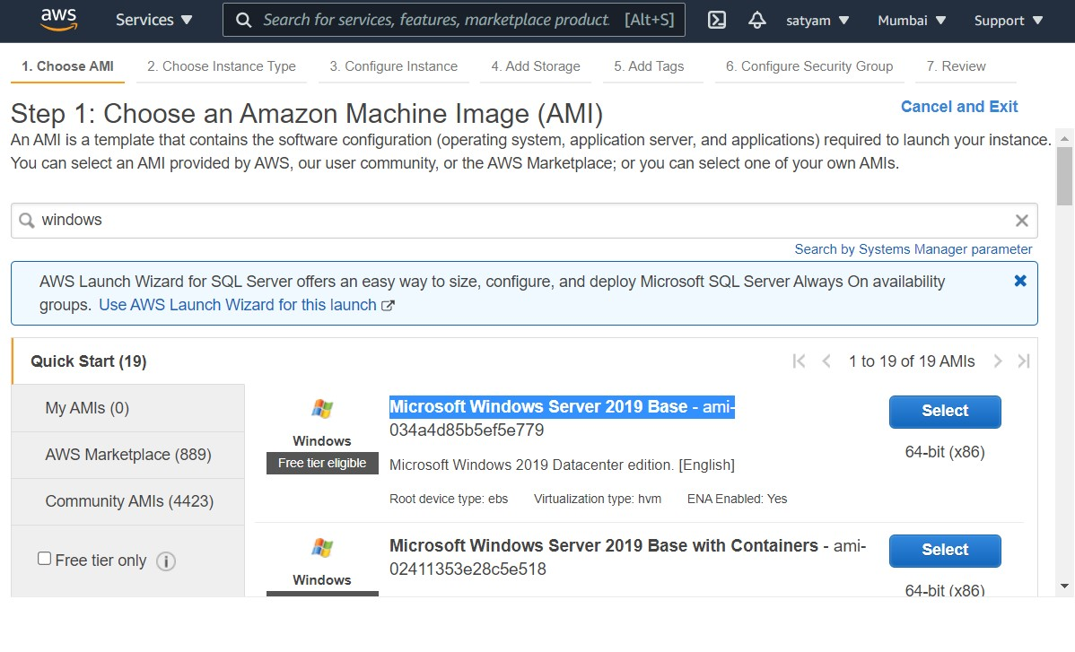

**Select IAMrole WHEN CREATE AN INSTANCE:-**

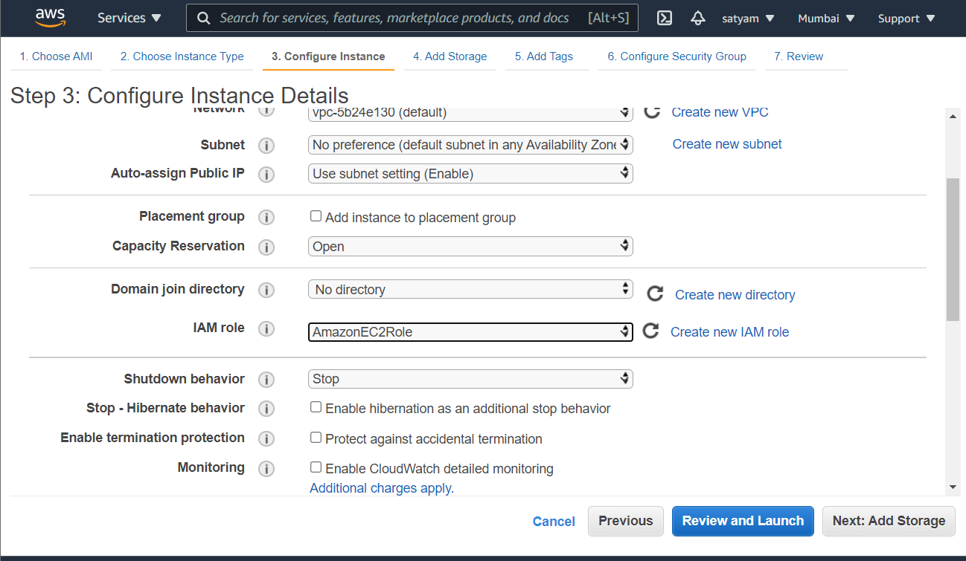

* Press security and then press get window password and select pem file means keypair file and then press decrypt password.

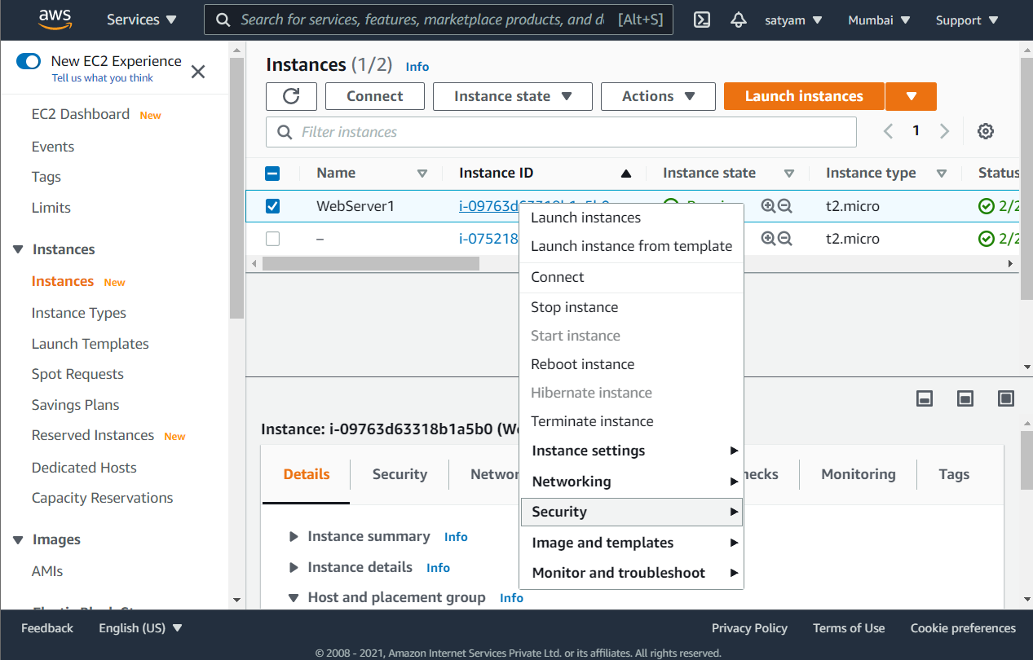

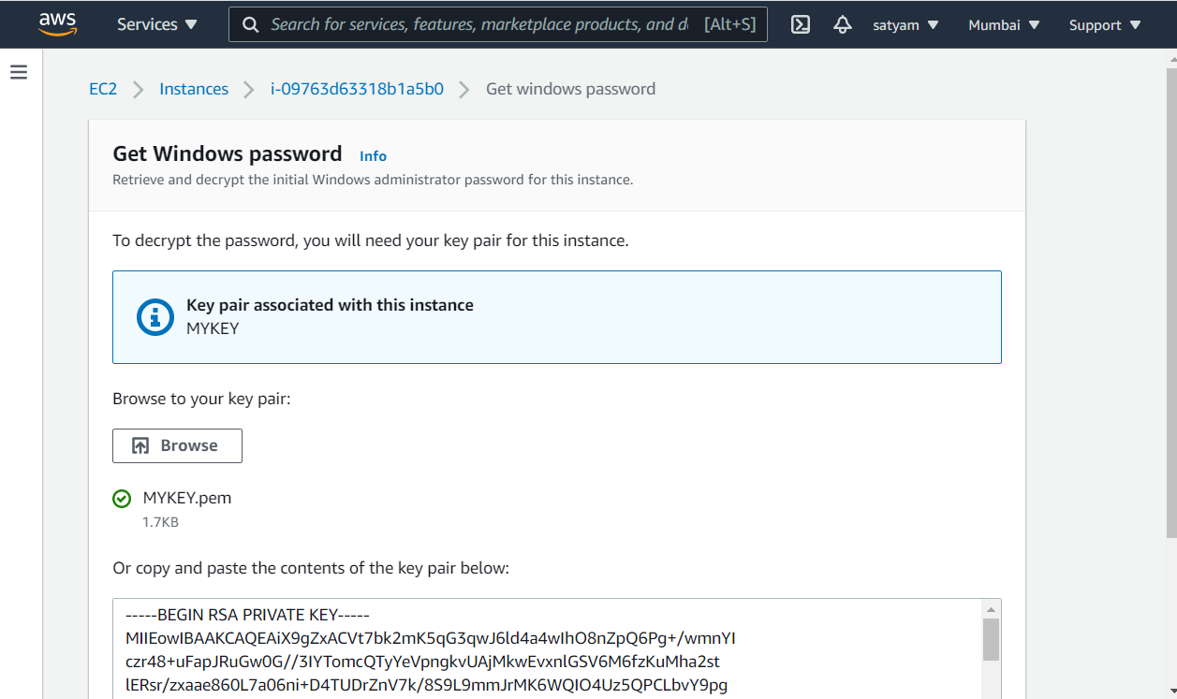

* **Copy a password**

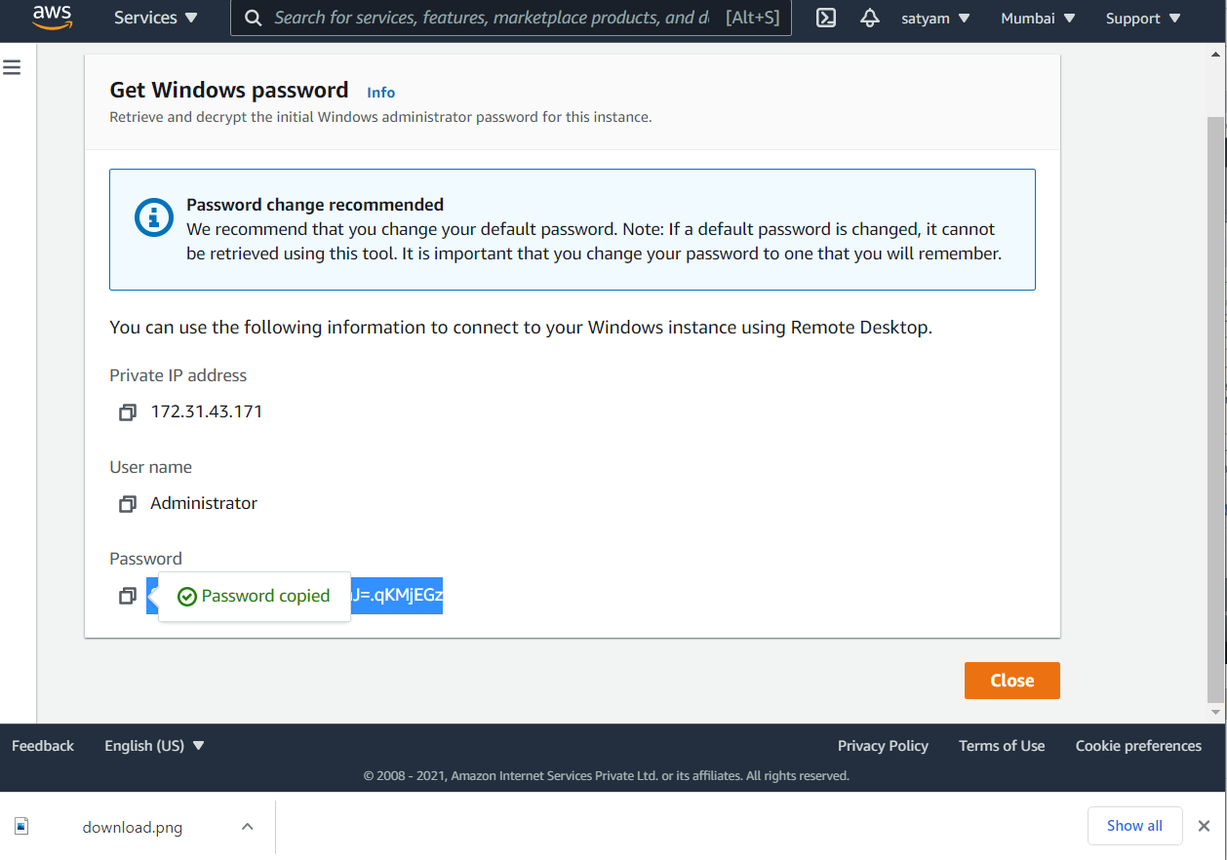

* **Go and connect remote desktop file & then download remote desktop file .**
* **Copy password also**

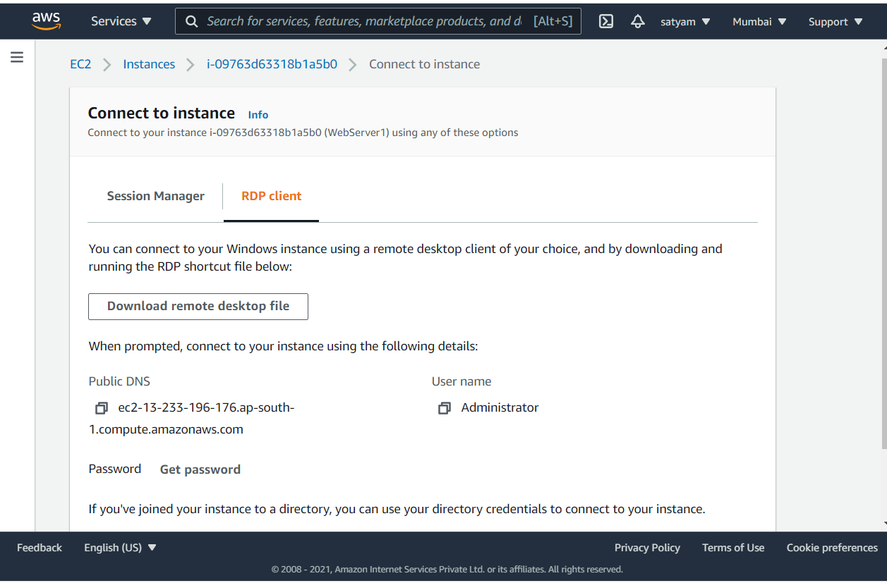

* **Open downloaded remote desktop file & Paste the password**

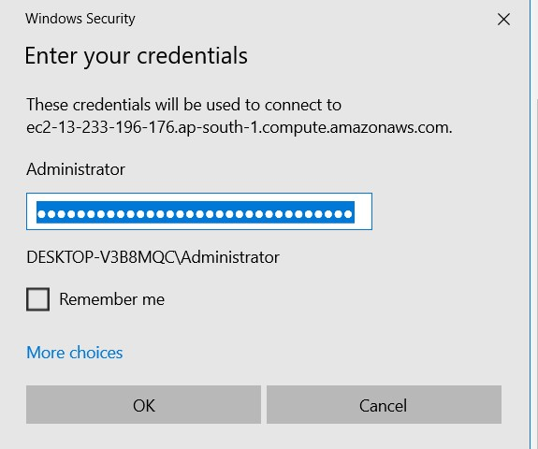

* **New window instance will create**

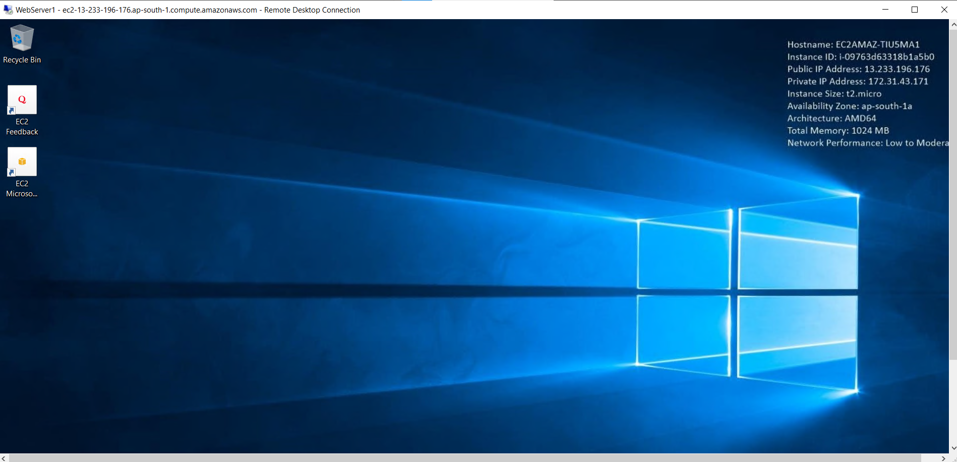

* **Go to aws service and search system Manager and open it.**

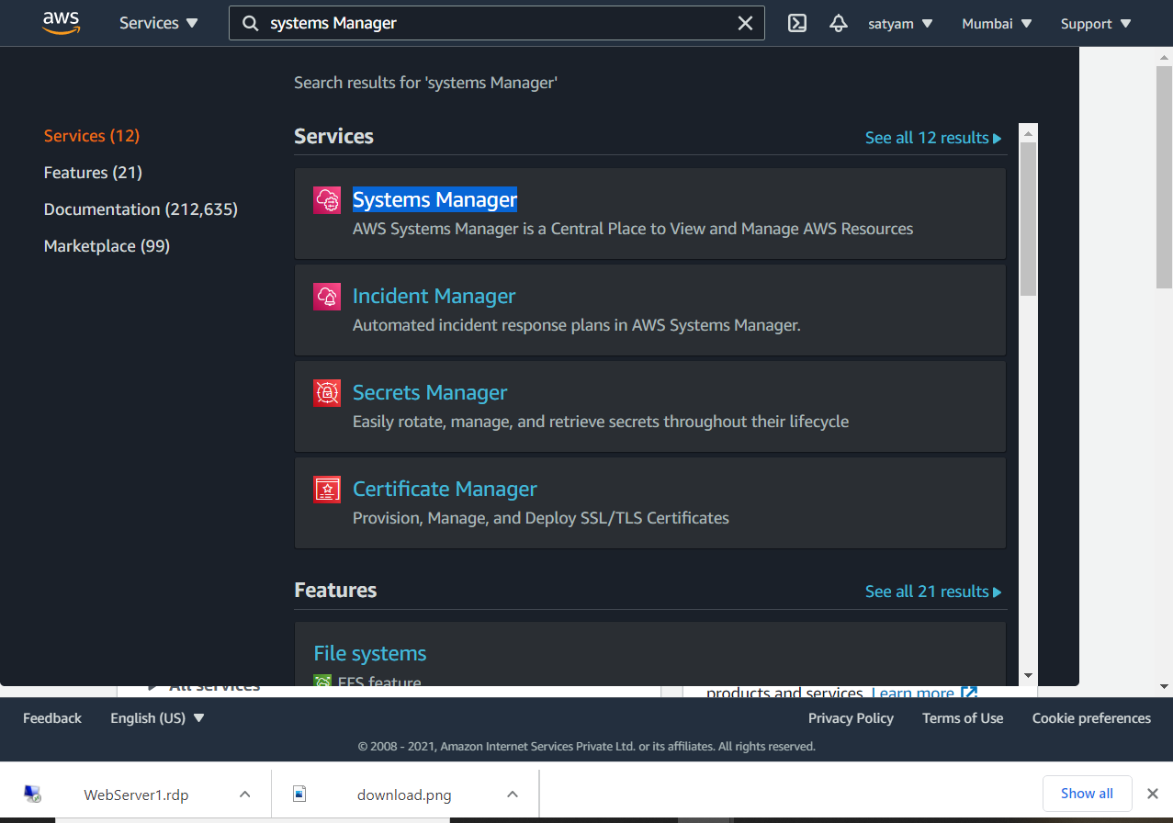

* **After open system manager searched managed instances and open it.**

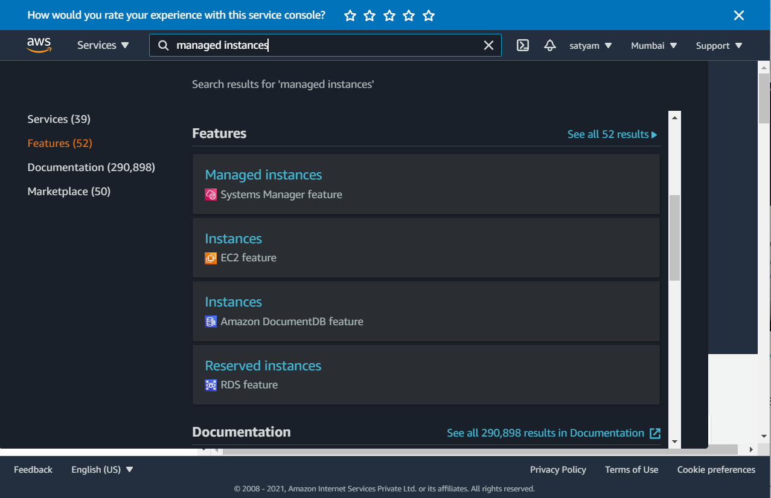

* Select AWS-CONFIGUREAWSpackage

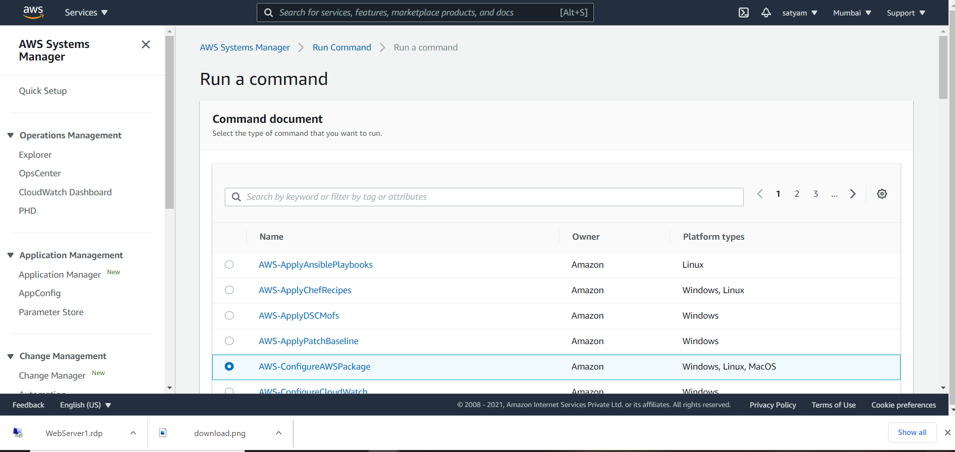

* Change Name

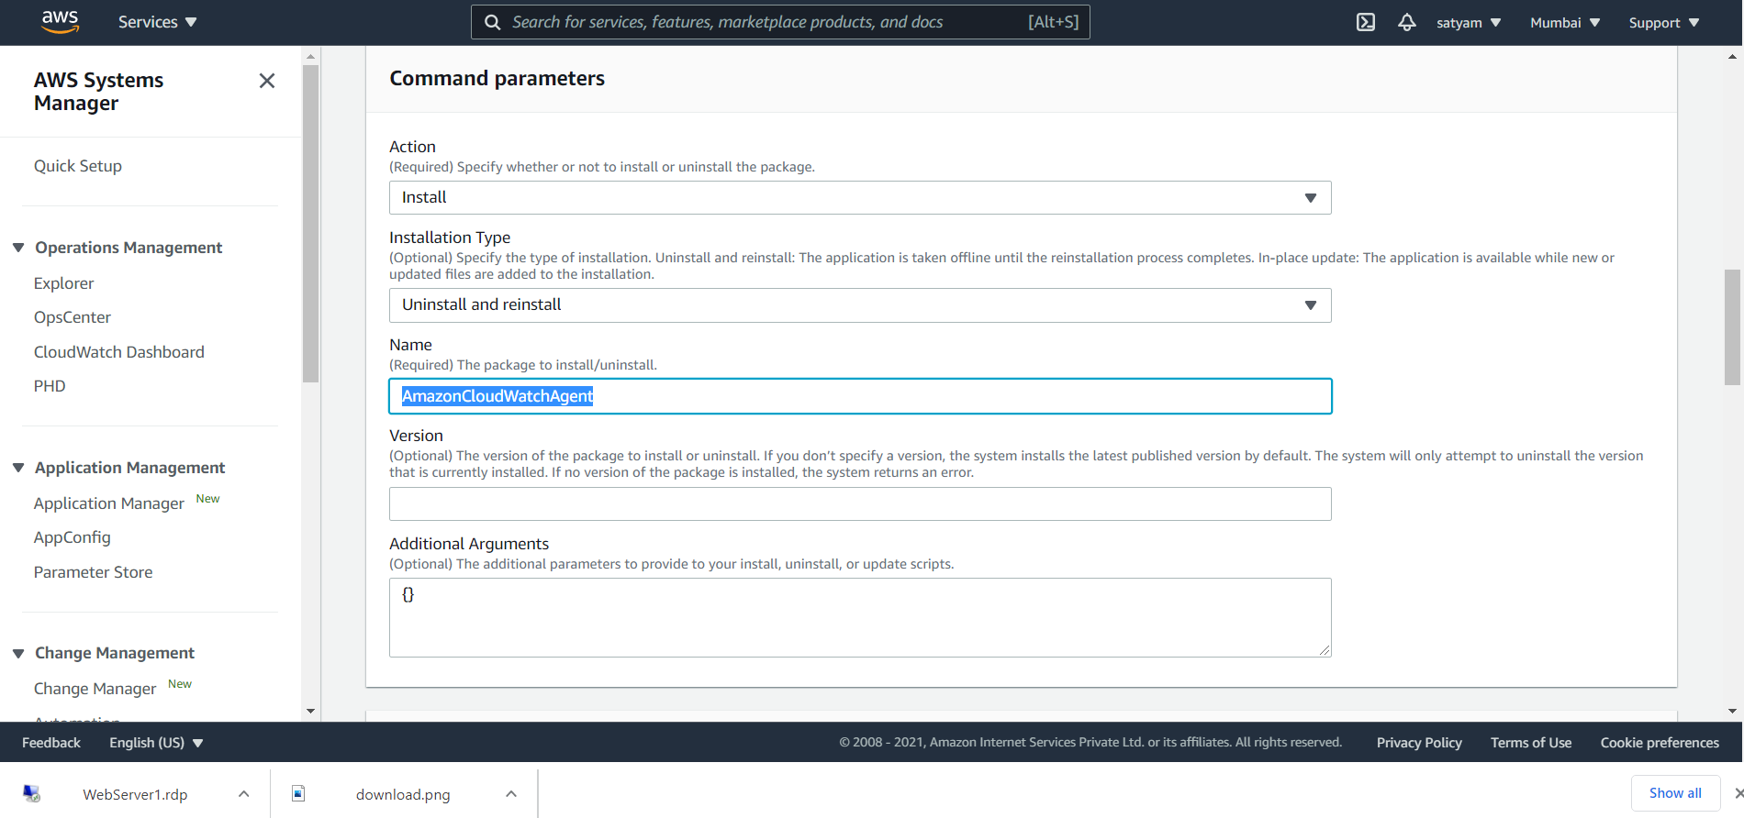

* **Select instance and view output**

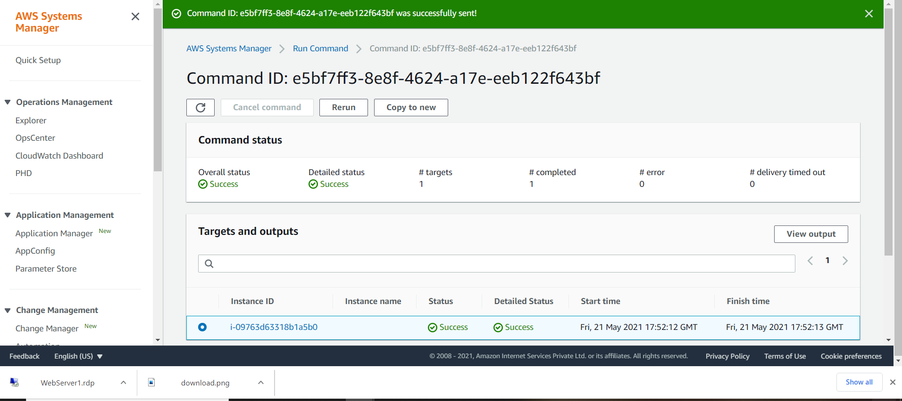

* **Open view output and you see in step 2 output agent has successfully installed.**

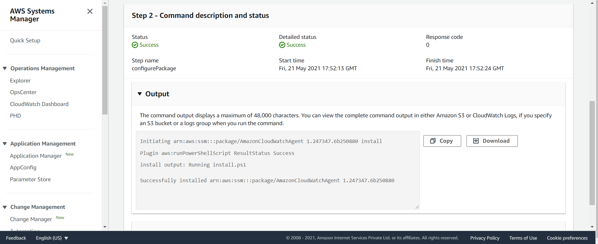

* **Open remote Desktop connection and go to this path you see AmazonCloudWatch agent has installed previously not installed it**

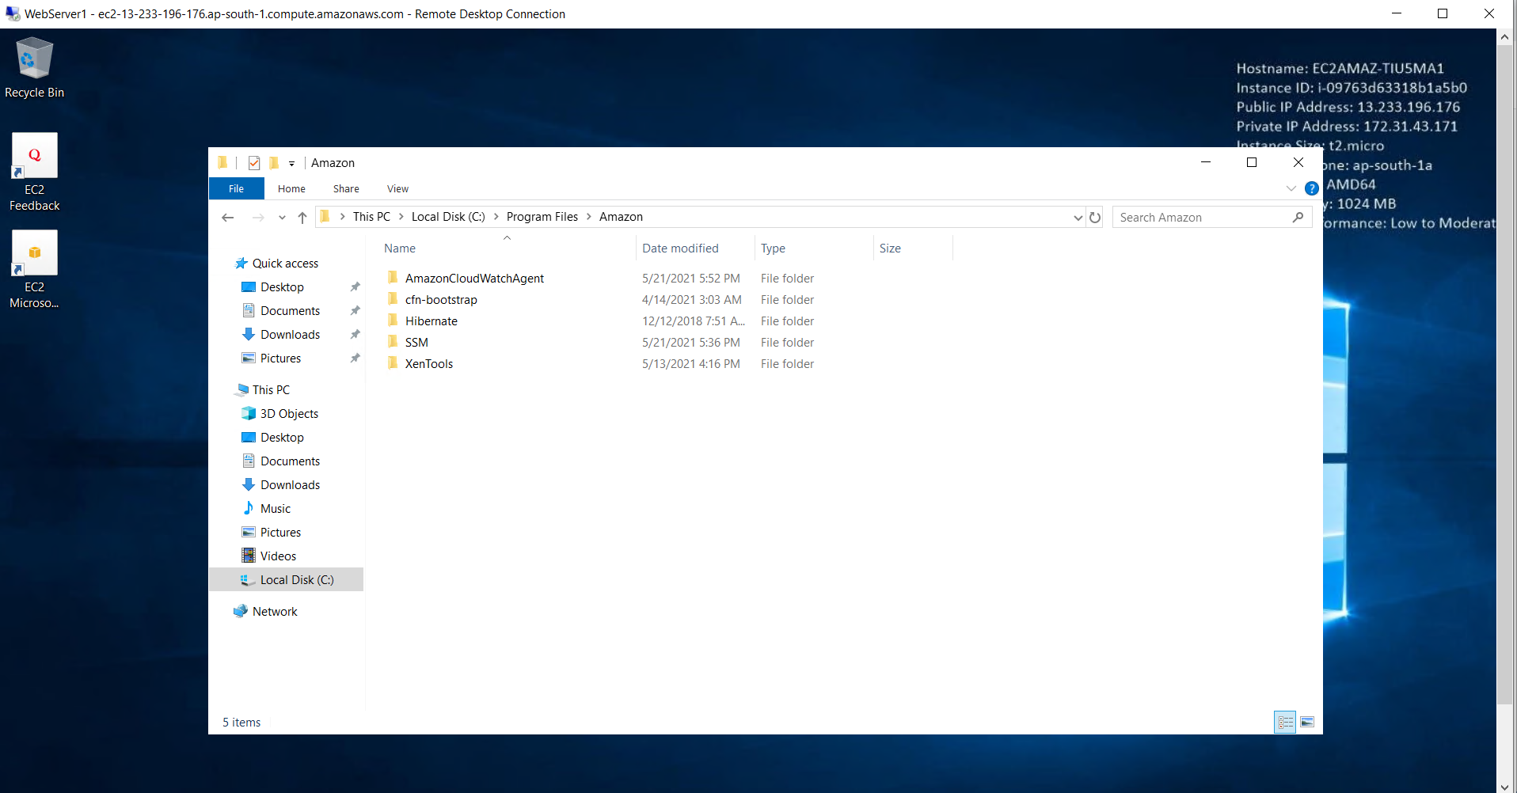

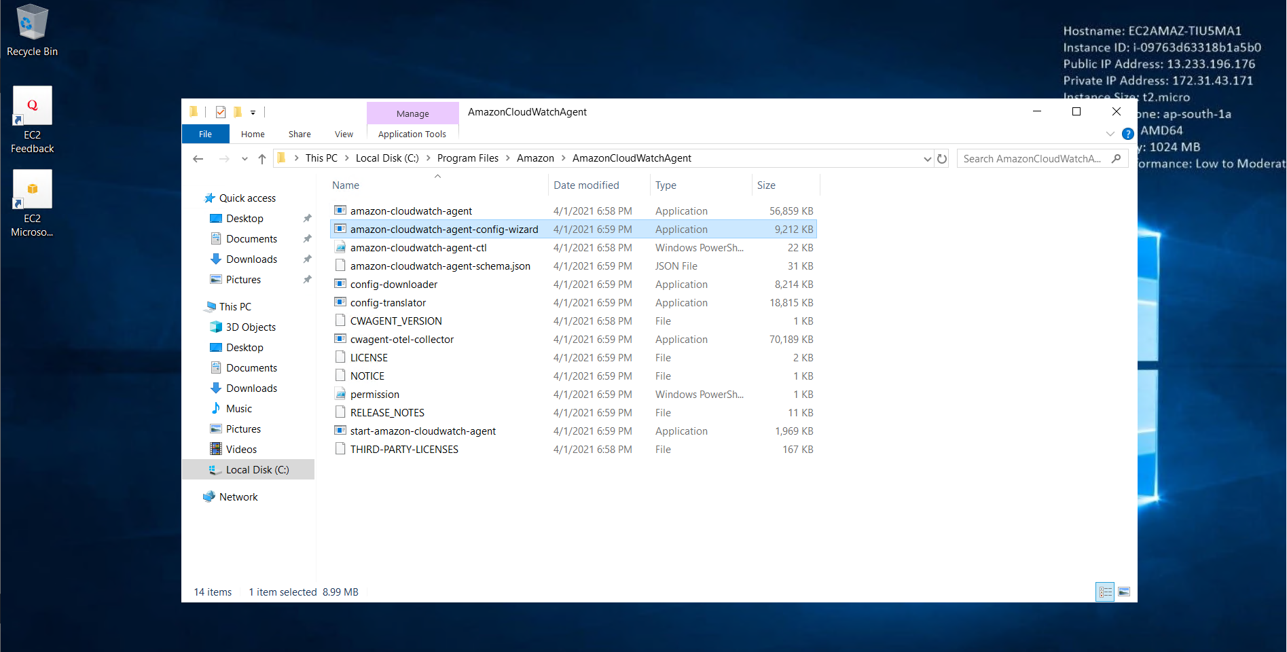

* **We go the command prompt in remote desktop connection and open path and run dir & then in next command we open amazon-cloudwatch-agent-wizard.exe**

